**Business Talk - Recommended Changes as of 25.12.2025**

1. **Main Header Screen:**

a. The Admin Login option should not be visible on the menu bar.

b. Change the background color from cream to pure white.

c. Use a larger Business Talk logo and remove the text “Business Talk” currently highlighted in maroon color.

d. Set the font color of all headers to dark black.

e. Update the platform logos to their original designs and arrange them in the following order:

i. YouTube

ii. Apple Podcasts

iii. Amazon Music

iv. Audible

v. Spotify

vi. SoundCloud

f. Remove the page line that includes Purple, Maroon, or Blue colors.

g. Mention the following text **above** all podcast logos:

Welcome to Business Talk, your premier podcast for cutting-edge trends, groundbreaking research, valuable insights from notable books, and engaging discussions from the realms of business and academia. Whether you're an academic scholar, researcher, business professional, or entrepreneur, our episodes will inspire you to question the status quo and spark actionable ideas. Our goal is to deliver valuable research insights from the world’s renowned scholars, sharing their unique perspectives and expertise.

How do we select our speakers?: The Business Talk committee identifies speakers after a meticulous screening process. These experts are then invited. That is, participation as a speaker is by invitation only. We remain committed to delivering free, high-quality content to our research community and are dedicated to maintaining this model in the future.

​​​

Brought to you by Global Management Consultancy, we are committed to driving innovation and excellence in the business community. The podcast recordings are available in both video and audio formats on this webpage. Simply click on the respective channel icons and immerse yourself in the world of learning!

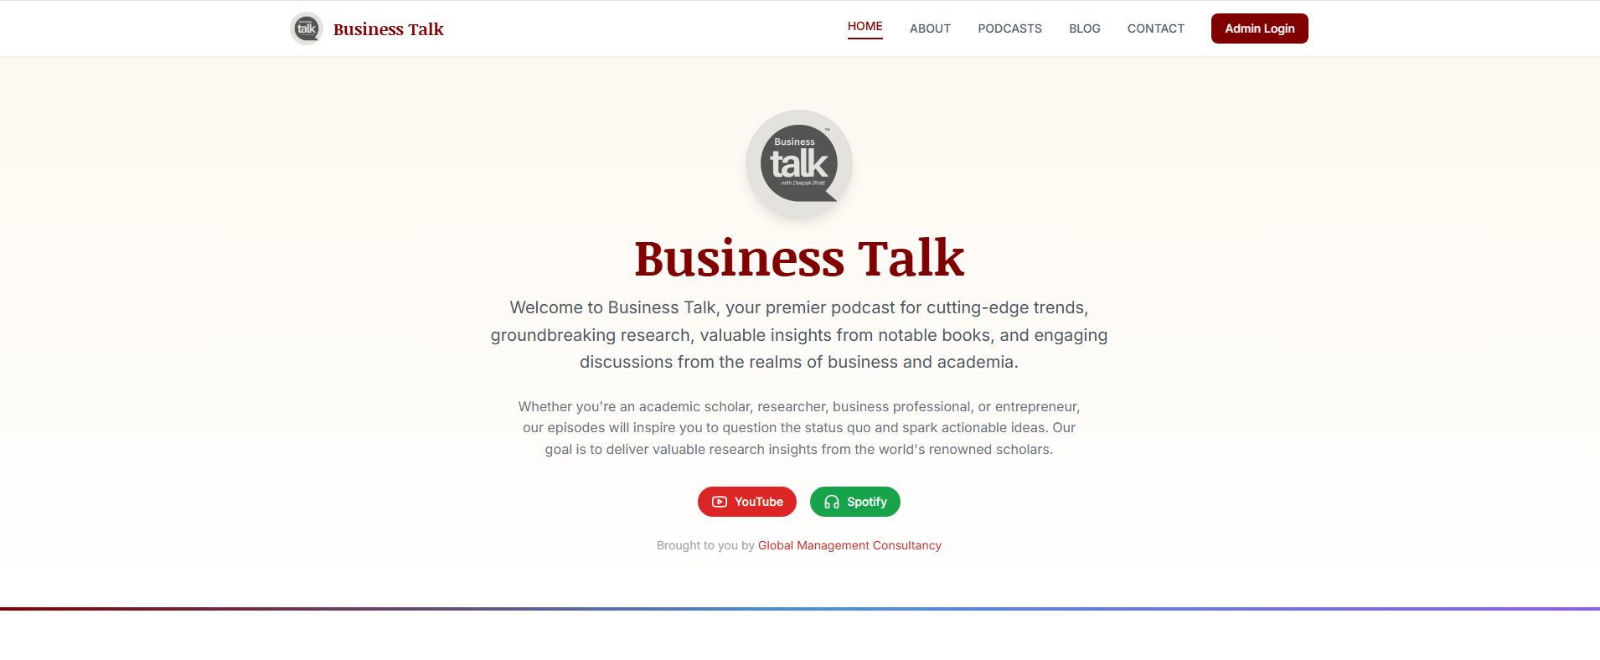

1. **Upcoming Podcast Episodes:**
2. Remove the line: “Join us for these exciting conversations with world-renowned scholars and thought leaders…”
3. For all upcoming episodes, use only high-resolution images in a larger size as shown in the sample below. You can keep two big size images together in a box. Only the images should appear – not the box with icons etc..

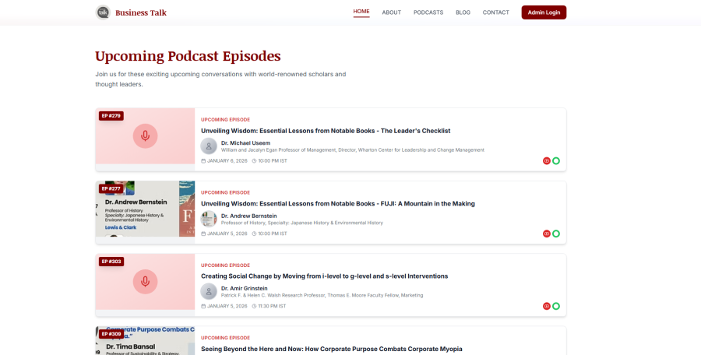

[**Old webpage**](https://www.deepakbbhatt.com/businesstalk)

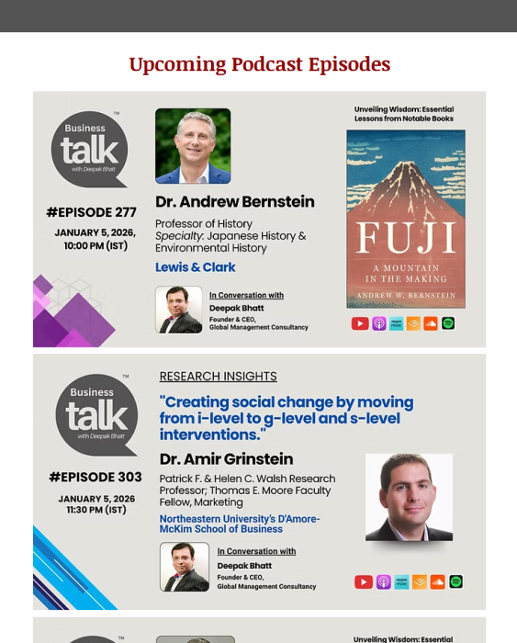

1. **Episode Highlights: Best of Our Previous Podcasts**
2. Keep this text in single line – **Explore our archive of insightful conversations with academic scholars across diverse research disciplines.**
3. Keep all fonts in Black and in a visible size.
4. Inside the Episode Box:
5. Keep **EP #309** tab in line with date in all episodes.
6. Increase the size of the text “Click Here to Watch.”
7. Increase the overall size of all boxes and display only three images per row.
8. Remove the purple design from all boxes.
9. Use original logos of all audio platforms in the following order: Apple Podcasts, Amazon Music, Audible, SoundCloud, and Spotify.
10. Display at least 50 episodes on the front page, with older episodes accessible via a “View All Episodes” link.

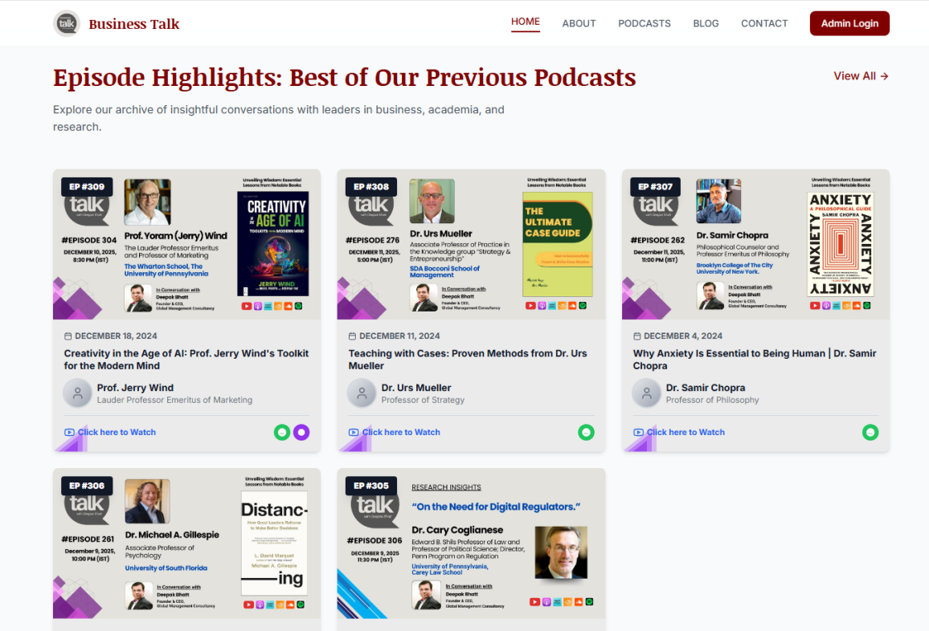

1. **Never Miss and Episode**
2. Revised text: Stay Updated with Every New Episode.
3. Revised text: Stay informed with the latest insights - subscribe to Business Talk on your preferred listening platform.
4. Logos:
   1. Subscribe on YouTube: Perfect, no change
   2. Listen on Spotify: Perfect, no change
   3. Listen on Apple Podcasts
   4. Listen on Amazon Music
   5. Listen on Audible
   6. Listen on SoundCloud
5. Keep the button color of all logos similar to their original logo color.
6. Footer (Black):
   1. Listen On: Keep all platform logos (mentioned above)
   2. © 2026 Business Talk. All rights reserved.
   3. Quick Links: Keep only three tab – Home, Blog and Contact

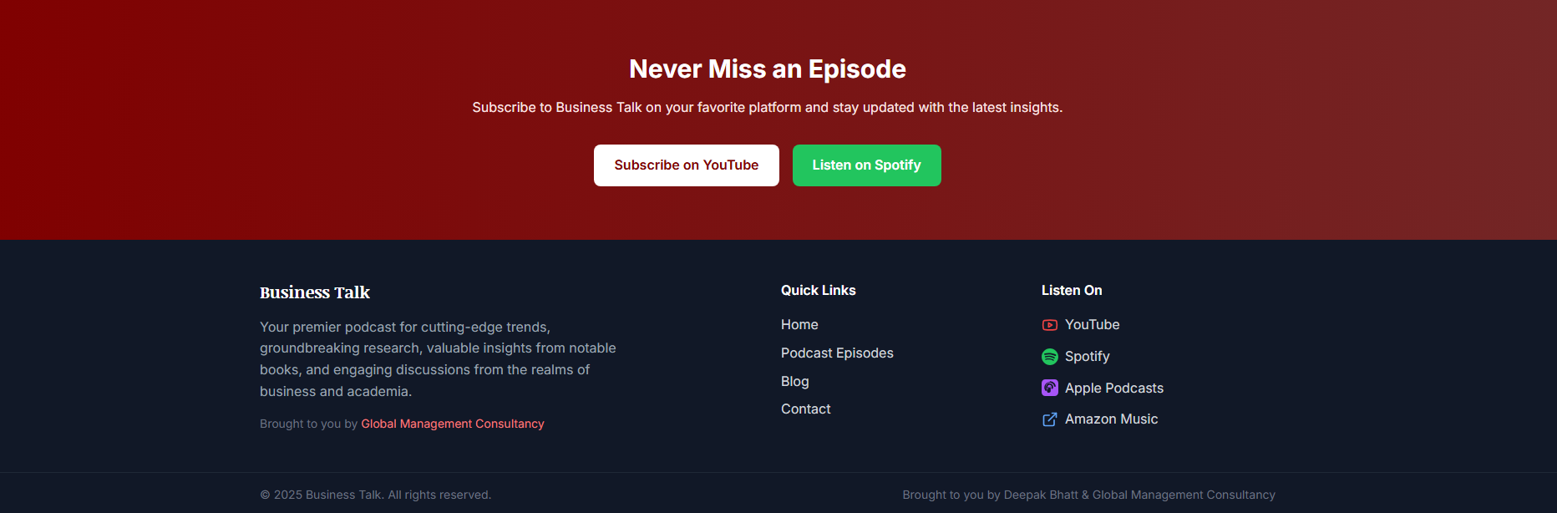

1. **Past Episodes**
2. Revised text: Watch our… **Discover Insights from our past episodes.**
3. Increase the average size of the above line.
4. Keep **EP #309** tab in line with date in all episodes.

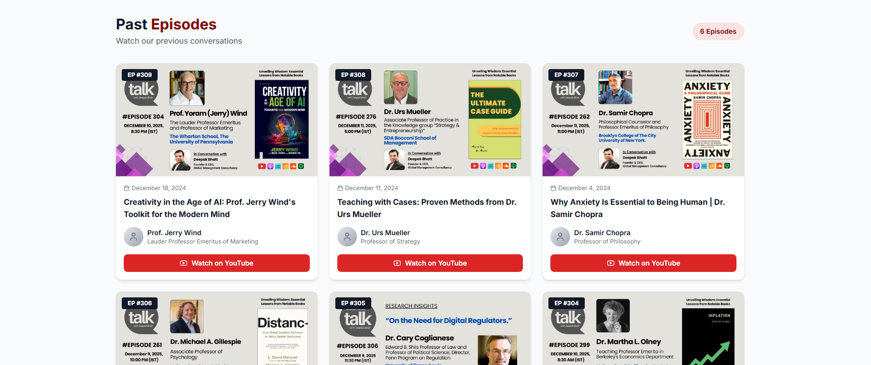

1. **About**
   1. Admin Login Rights of About Page (for self-update)
   2. Remove this – A bit about me, Hello, I’m Deepak Bhatt.
   3. Keep white box as it is and remove all texts
   4. Remove this tab – Explore More and all buttons
   5. Remove this - Copyright @ 2025 by Deepak Bhatt

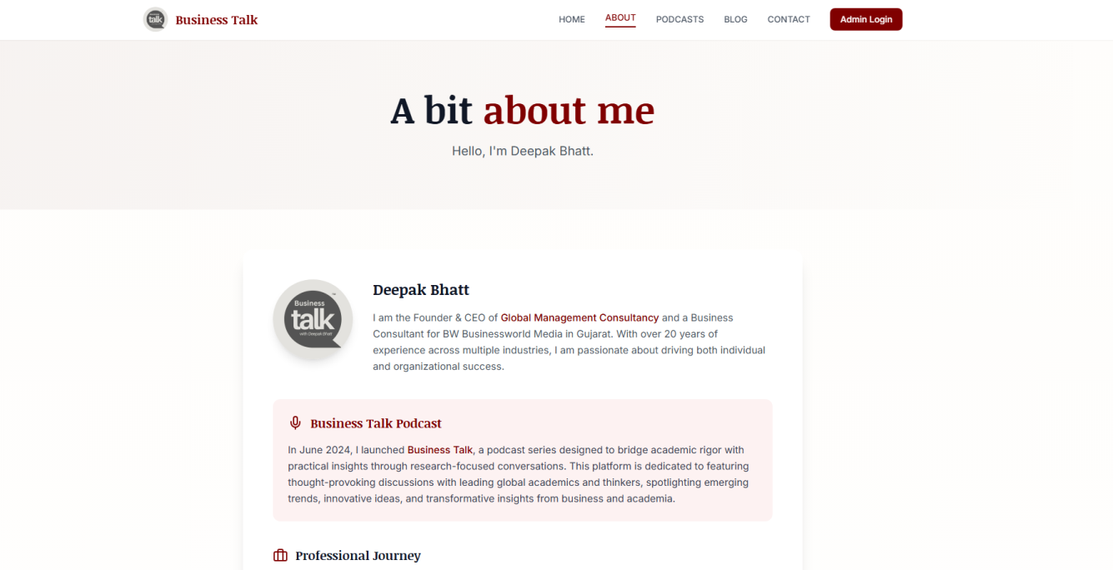

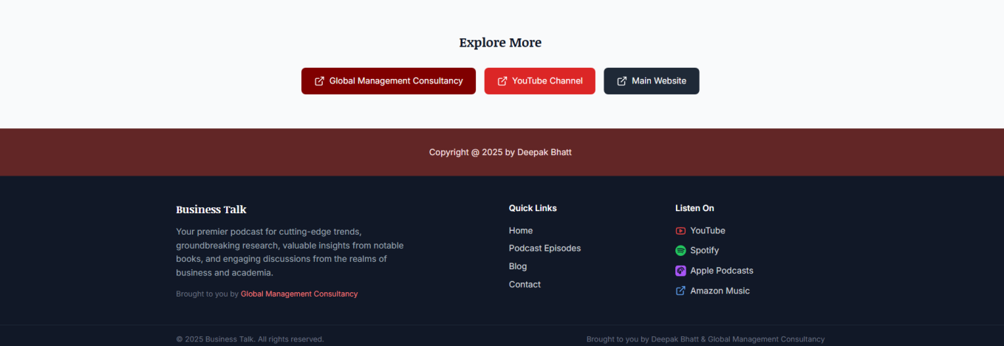

1. **Blog**
2. Title: Perfect
3. Revised text: **Gain valuable insights and thought leadership from our dialogues with leading academics and research scholars.**
4. Give edit/deletion rights of Blog section:
   1. Adding new Category
   2. Upload Image – Image URL is not required
   3. Font Type, Size, Justify, Center, Left, Right alignment box
   4. Hyperlink option as well (similar to word format)
5. Revised title: **Latest Insights**

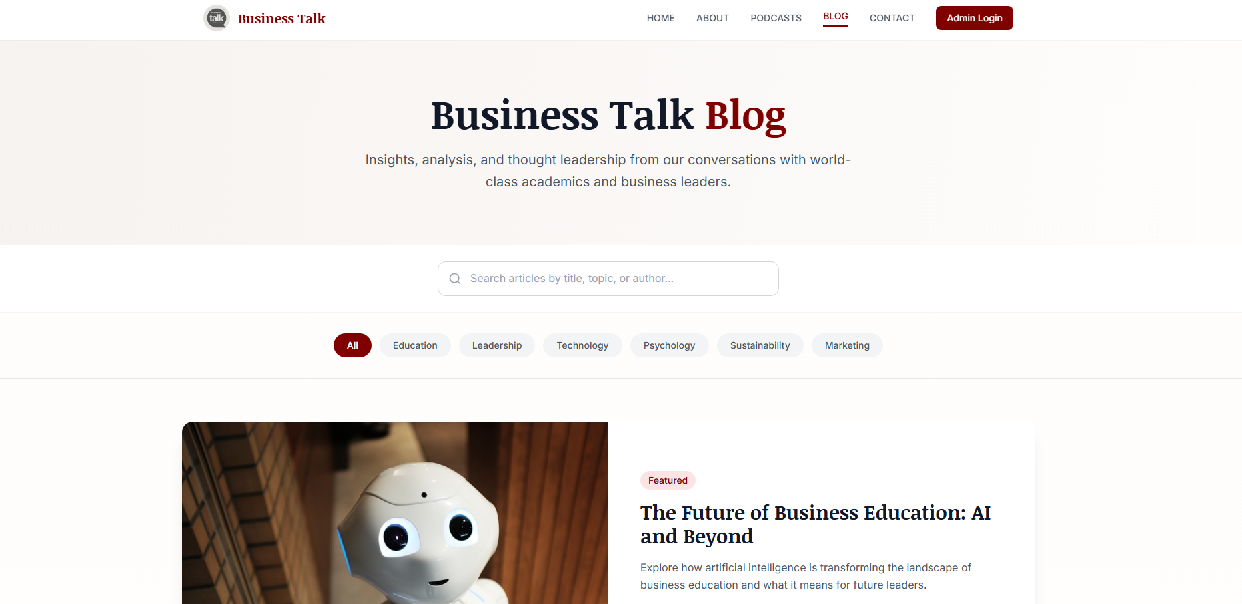

1. Keep the header image blank

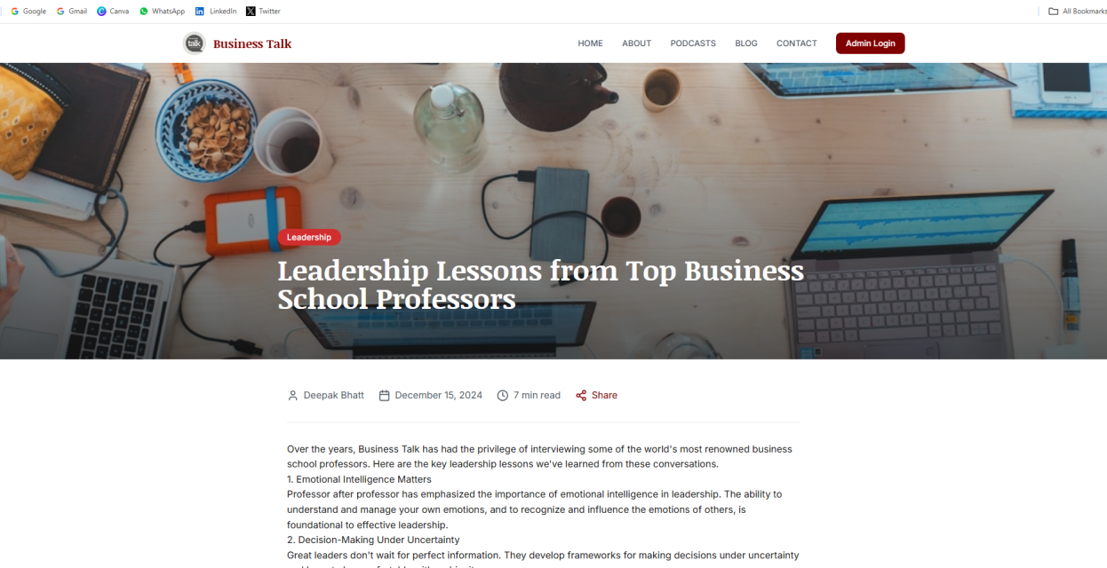

1. Remove – Stay updates with Business Talk
2. Revised text - **Join our newsletter to receive fresh insights, new podcast releases, and exclusive updates.**
3. Remove Explore More Content, YouTube Channel and Main Website tab

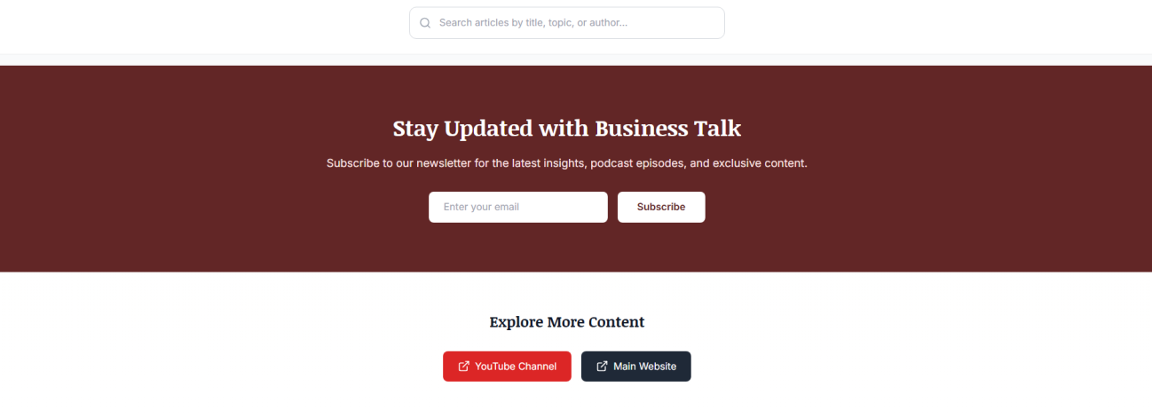

1. **Contact**
2. Get in Touch: Perfect
3. Revised text - Questions or feedback? We’re here to listen.
4. **Let’s Connect:**
   1. Revised text - Business Talk brings together thought leaders in academia and research scholars for meaningful conversations. Have something to ask or share? We’d love to hear from you.
5. Email Us:
   1. [hellomrbhatt@gmail.com](mailto:hellomrbhatt@gmail.com)
6. Website:
   1. [www.deepakbbhatt.com](http://www.deepakbbhatt.com)
7. Location:
   1. Ahmedabad, Gujarat (India)

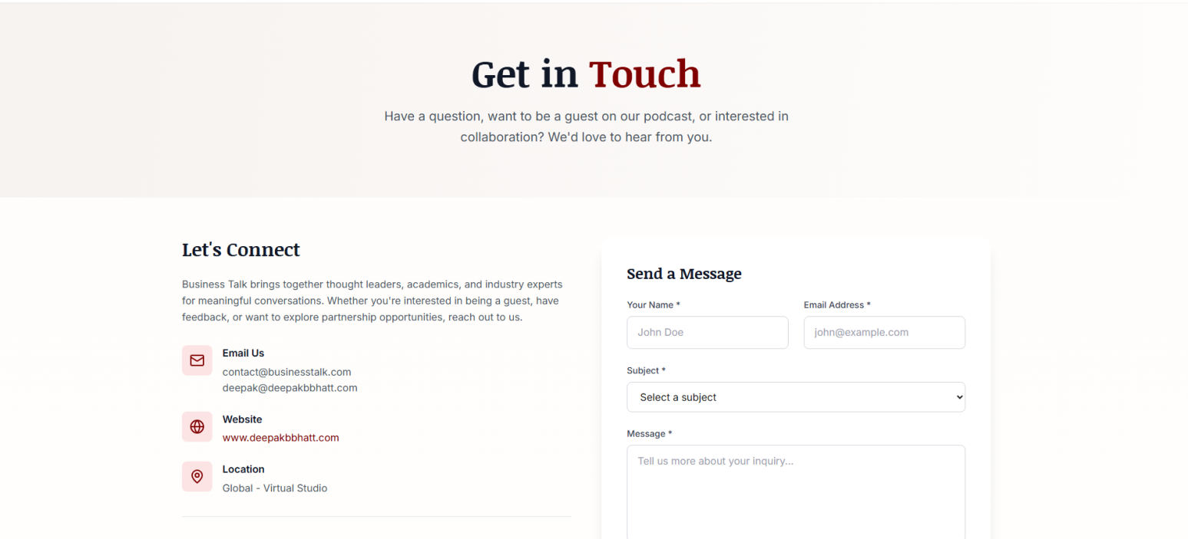

1. Remove Follow Us buttons
2. Remove – Want to Be a Guest?
3. Remove **Subject\*** tab from – Send a Message box

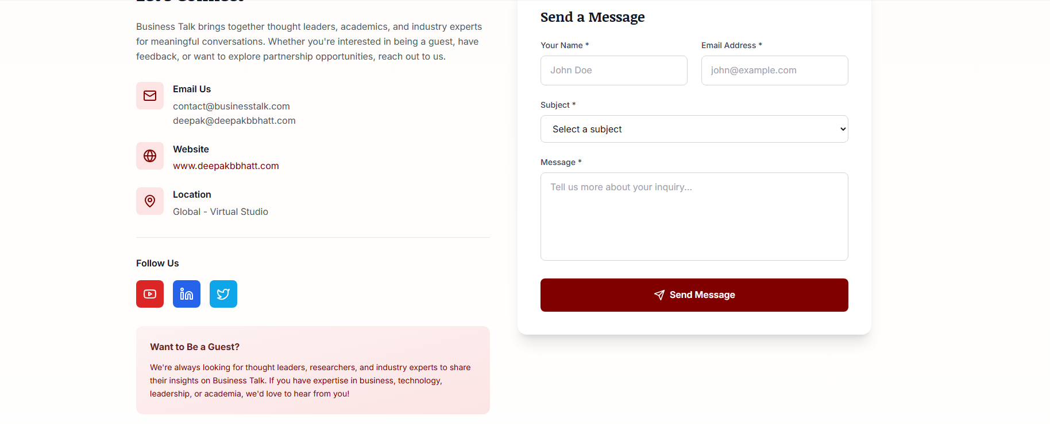

1. Remove - Frequently Asked Questions

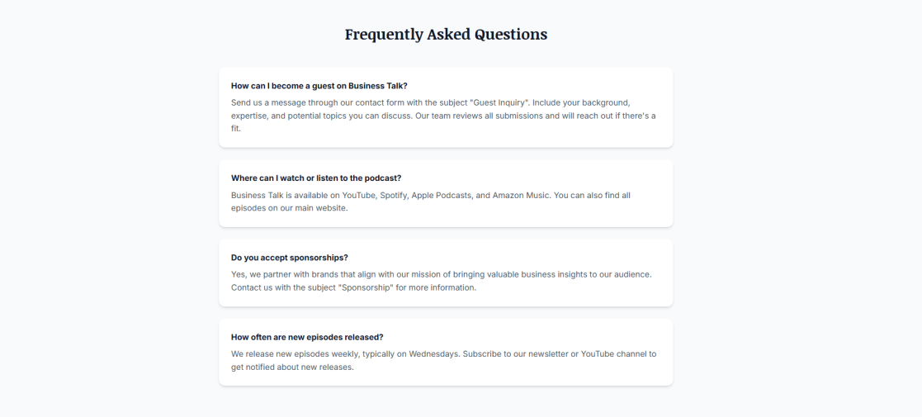

1. **Admin Login:**

**Podcasts Section**

1. **Download Summary Option:** Add a Download Summary feature in both Excel and PDF formats. This should include all previous episodes in a summary format. If feasible, include a timeline view of episodes within the document.
2. **Visitor Counter:** Add a Site Visitors Gadget near the Published Episode section. Display the total number of visitors to the website. If possible, include a country-wise visitor counter for geographic insights.

**Blog Section**

1. Blog Counter: Add a view counter to display the number of people who have viewed the blog. If possible, include a country-wise views counter for geographic insights.

**Menu Bar**

The Business Talk logo is not appearing on the menu bar.

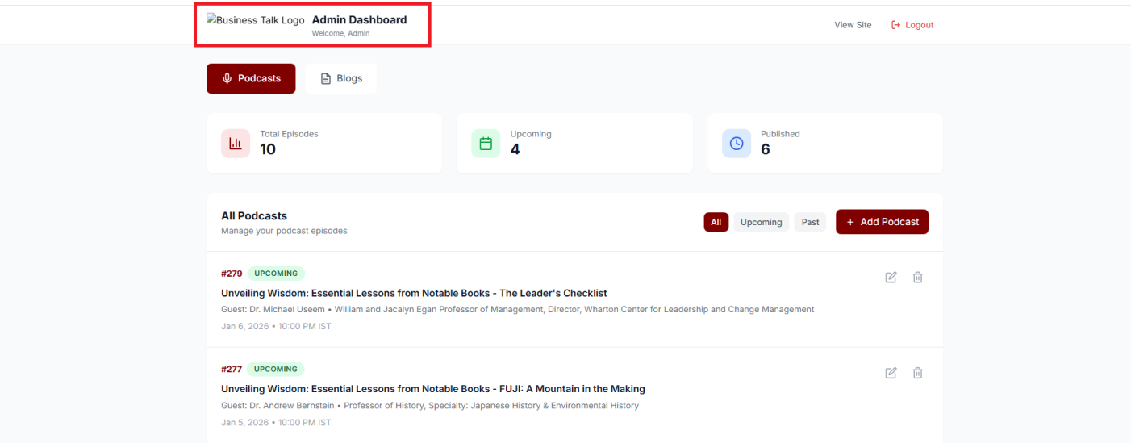

1. Keep Business Talk logo with slightly big size instead of MIC icon.
2. Revised text: **Log in to manage and update Business Talk podcasts.**

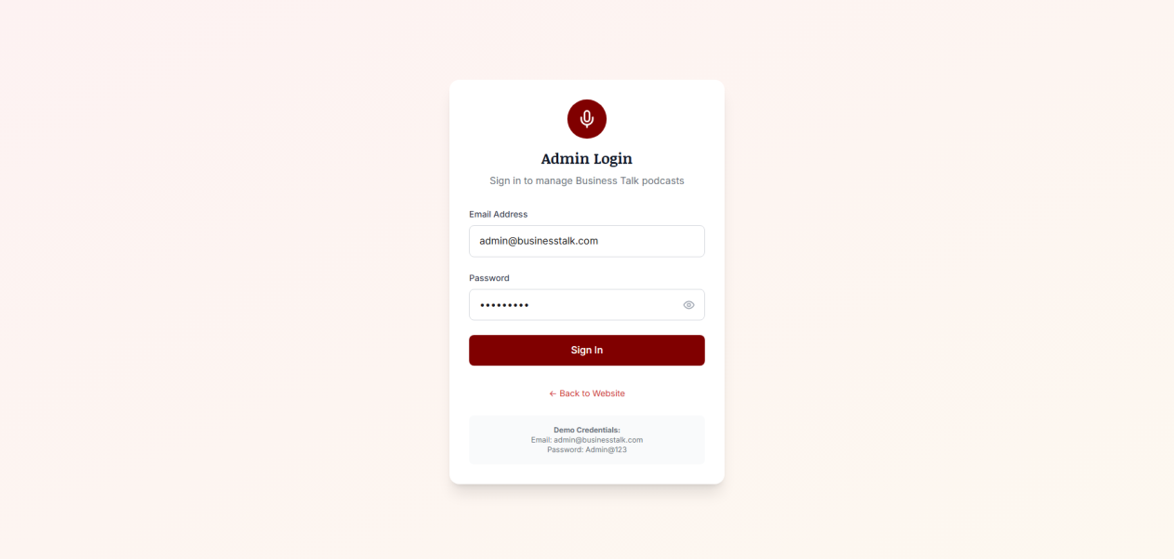

1. Platform Links:
   1. Provide Audible URL & SoundCloud URL

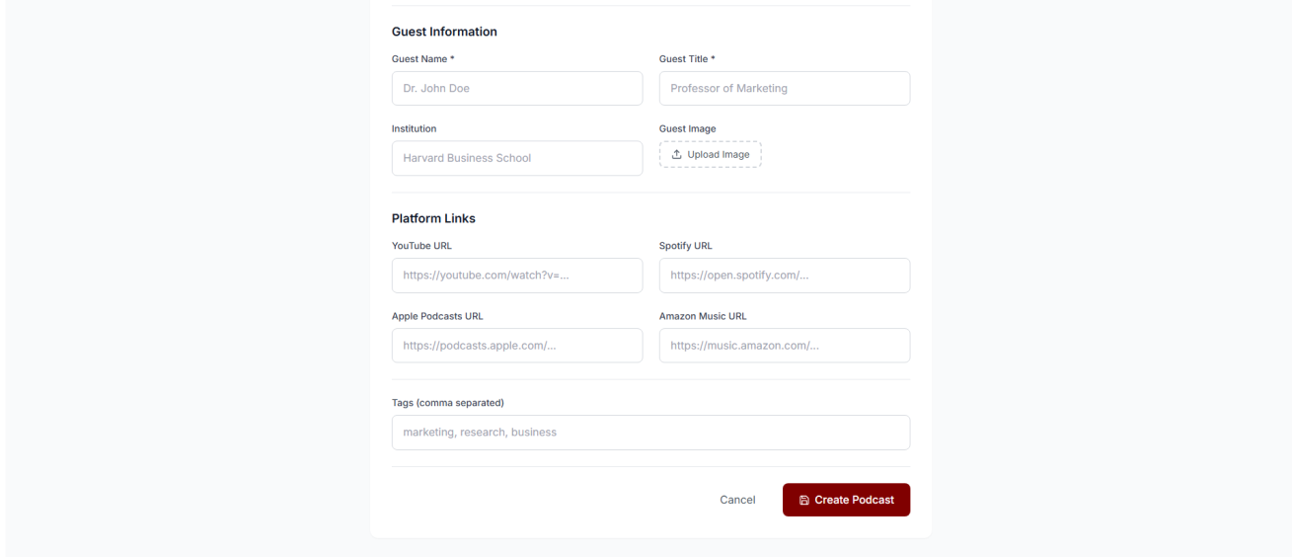

1. **All Platform URLs:**

YouTube: <https://www.youtube.com/@businesstalkwithdeepakbhatt>

Apple Podcasts: <https://podcasts.apple.com/us/podcast/business-talk/id1596076450>

Amazon Music: <https://music.amazon.in/podcasts/1803c906-ea83-406b-82c6-fcacd13873af/business-talk>

Audible: <https://www.audible.in/podcast/Business-Talk/B0DC5NTGMS?qid=1723093390&sr=1-1&ref_pageloadid=not_applicable&ref=a_search_c3_lProduct_1_1&pf_rd_p=2d02bc98-4366-4f94-99d9-5e898cda0766&pf_rd_r=419ZV0YE7KZNJTE21H1W&pageLoadId=FYjmdUY3osxvbszX&creativeId=b2592cc9-1111-40d9-9474-98f67c8075cc>

SoundCloud: <https://soundcloud.com/business_talk>

Spotify: <https://open.spotify.com/show/3IB2aXm9eZkLiSVaUZEQuK?si=M_9QZ3AlSC65B9HIMYXbmg&nd=1&dlsi=234010b1db6d4d14>